Linux task

- Create user with name Techie and provide sudo access to user.
Ans : useradd techie
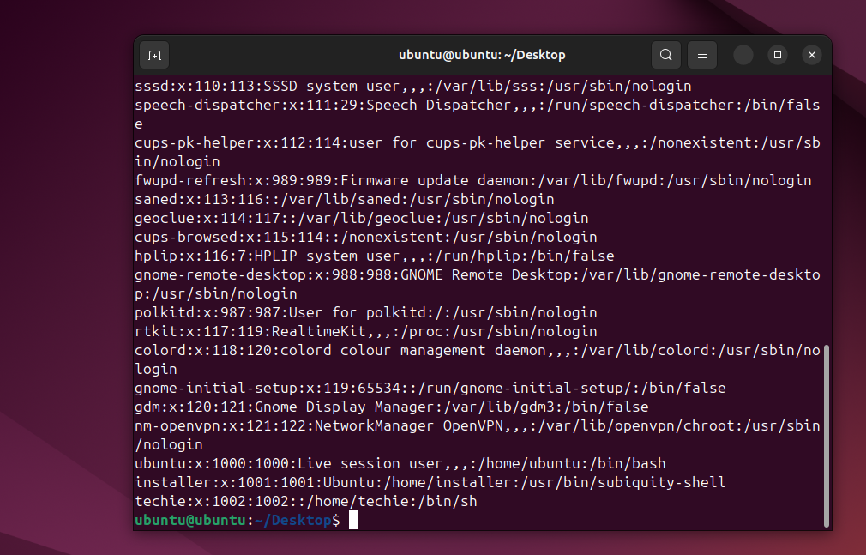
To able to provide access to user in sudo
Ans : entre the command vi /etc/sudoers and need to entre the user name and ALL=(ALL:ALL) ALL the save the file
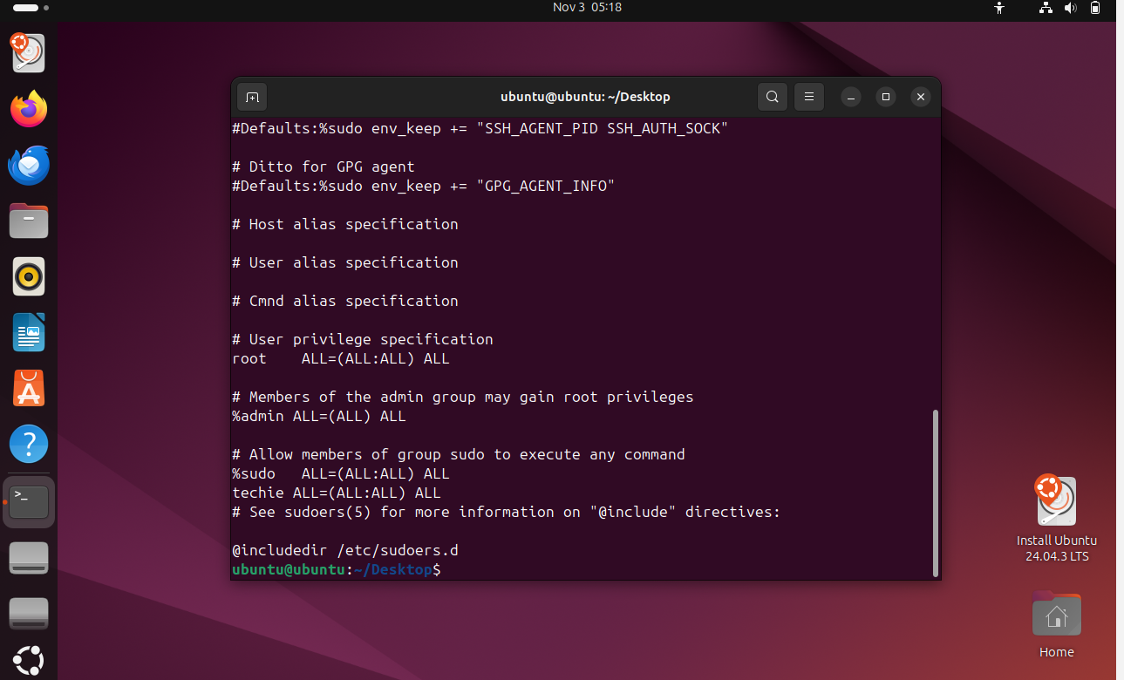

2 . Navigate to the home directory.
Ans : by using command cd ~ to go home directory
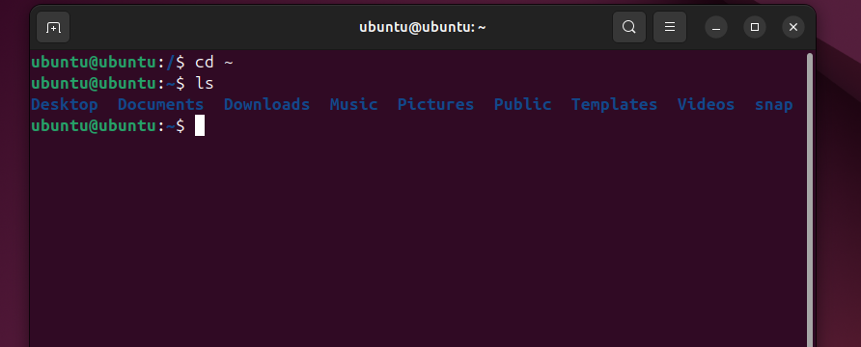

- Create a new directory.
Ans : by using the command mkdir directory name
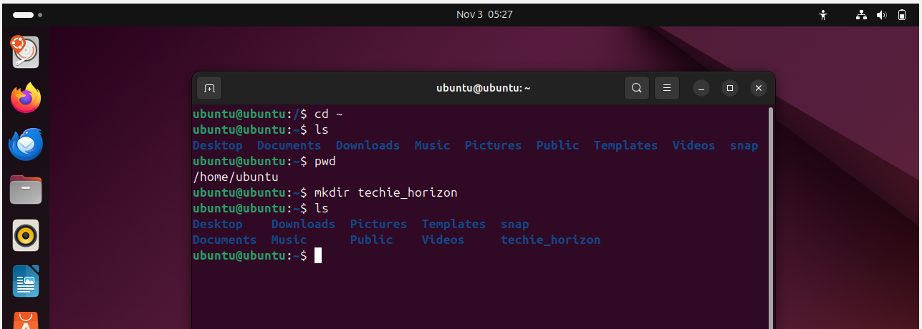

- List the contents of a directory
ans : using the command of ls


- Change the current directory
Ans : using command mv directory name /directory
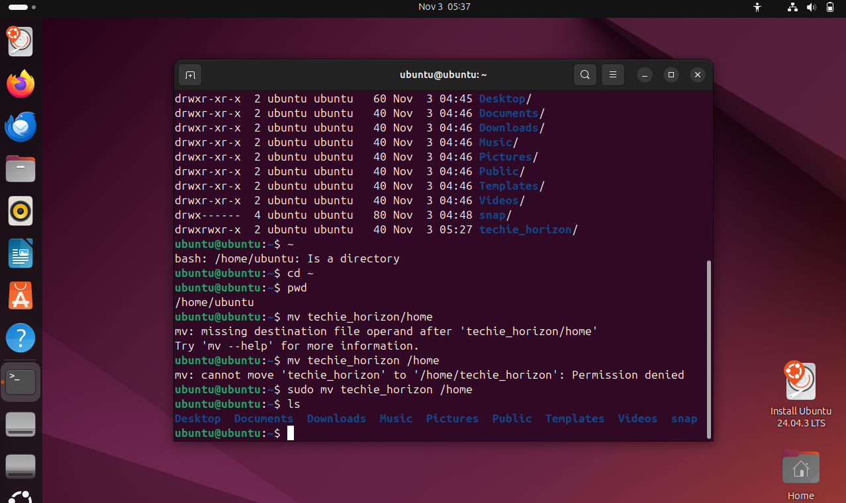

- Create a new empty file.
Ans . using command of mkdir and file name
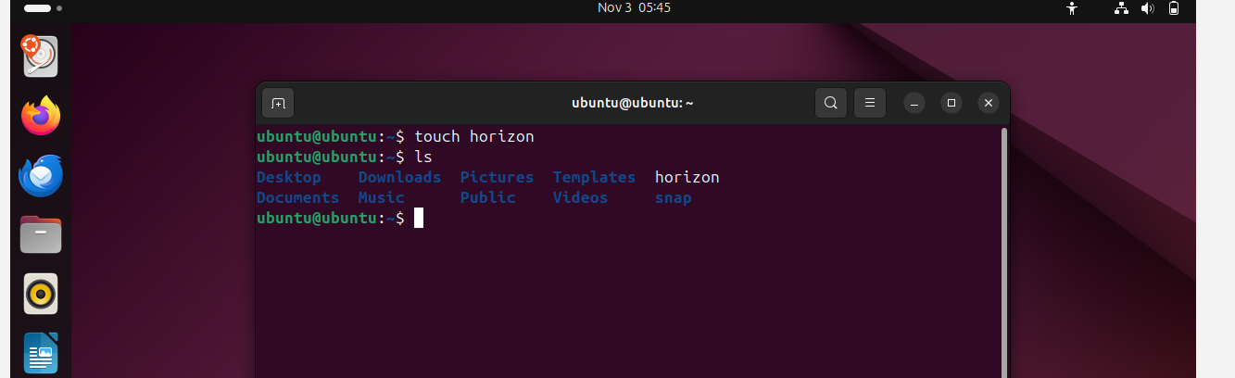

- View the contents of a file.
Ans . using cat file name to view file content 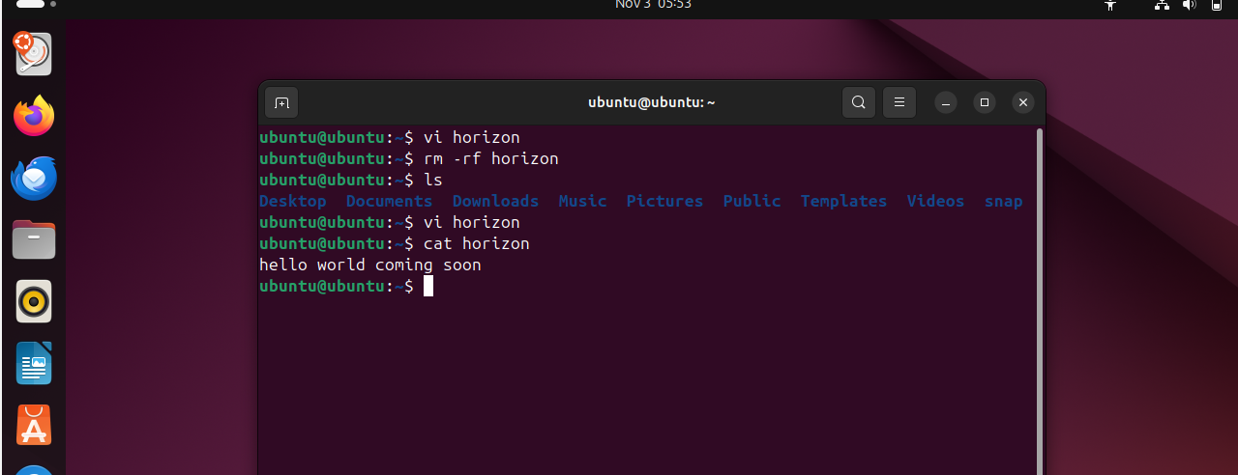

- Copy a file to another location.
Ans : using command cp file name directory
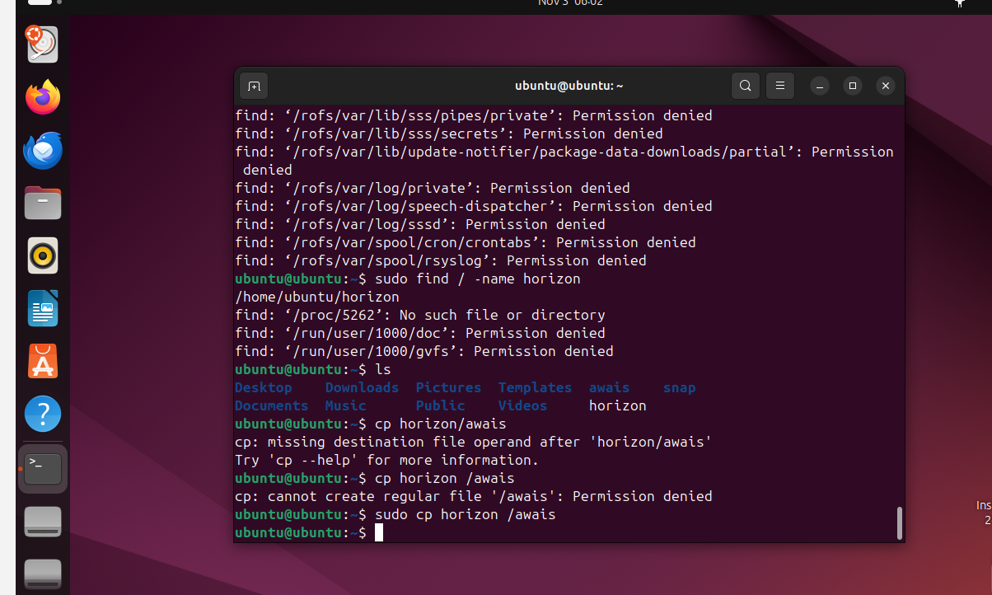

- Move a file to another location
Ans : by using command mv file name space directory name 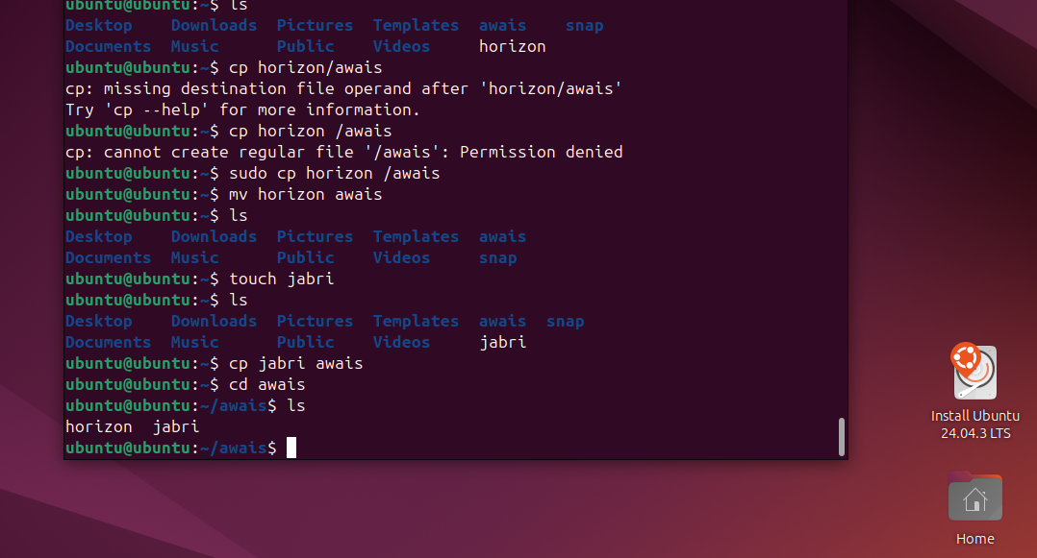

- Rename a file.
Ans: using mv old filename new filename
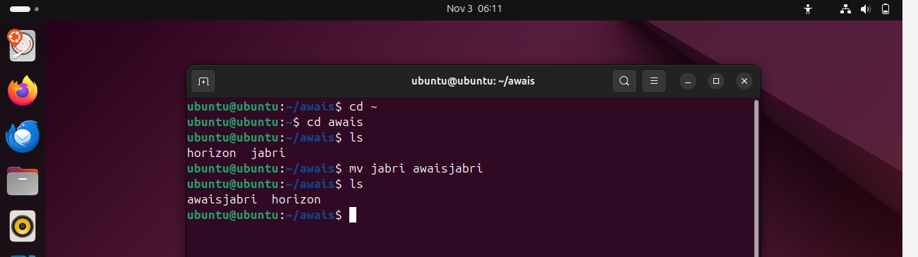

- Delete a file.
Ans : using command of rm -rf filename 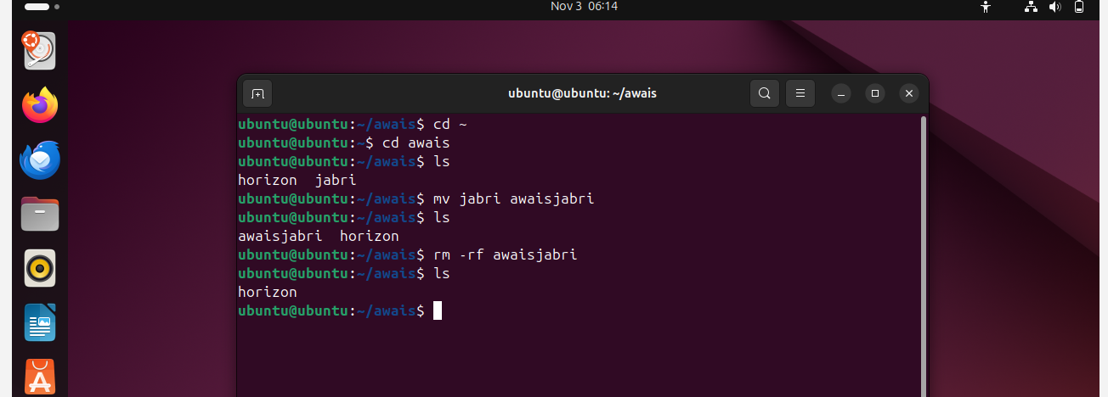
- Grant or revoke permissions on a file or directory.
Ans : using command of chmod permission file name
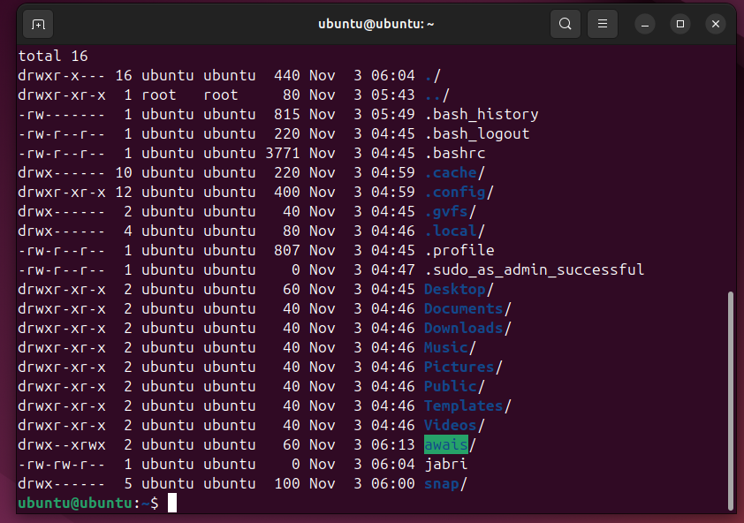

13.View the current date and time
Ans. By typing date
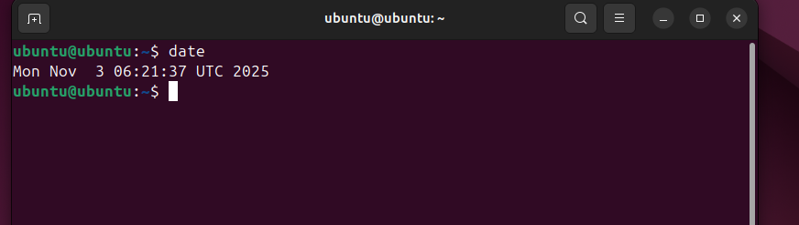

- Check the system uptime.
Ans: by using uptime 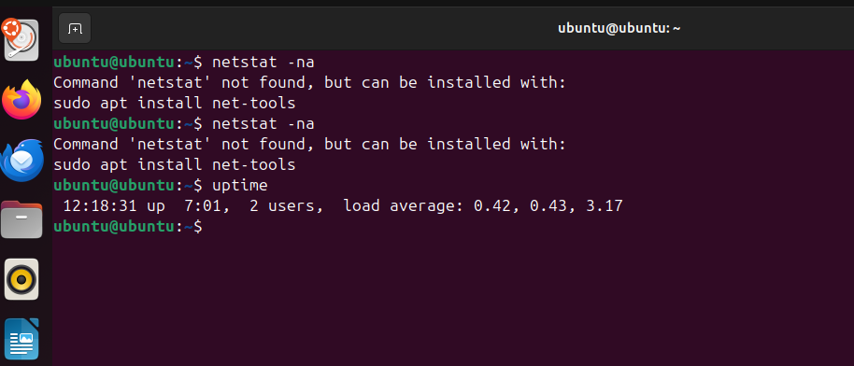

- View the running processes.
Ans : by using command of ps -ef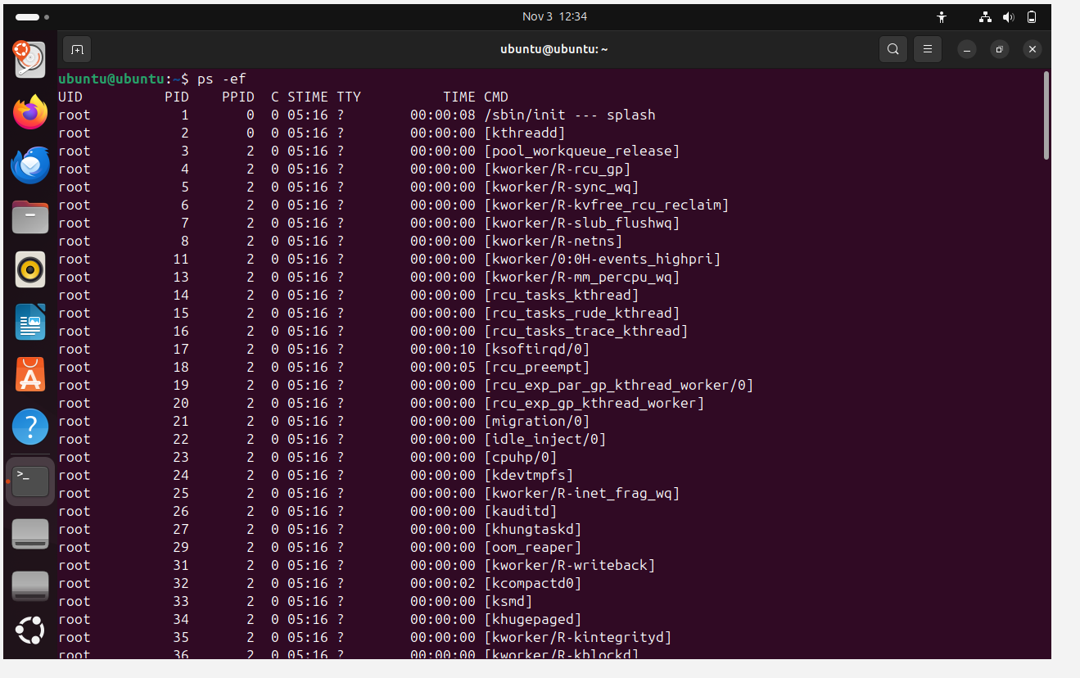

16. Kill a running process.
Ans . using command of kill -9 product id
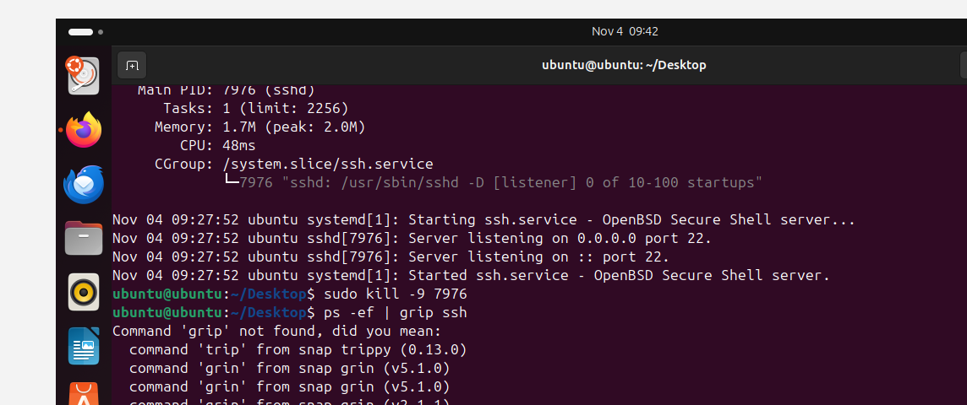

17.Install a package using the package manager (e.g., apt or yum).
Ans : to able to install the package need to use command of :apt install service name (nginx) -y
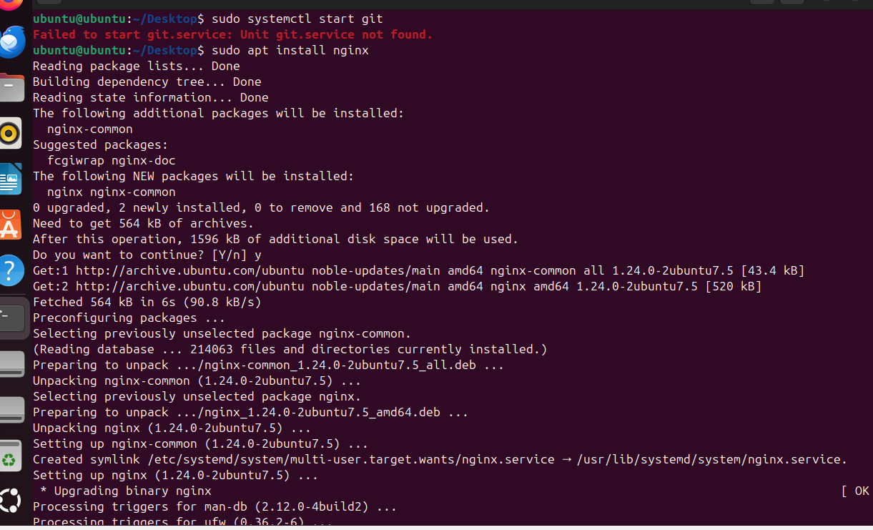

18. Update the system packages
Ans : using command of sudo apt update
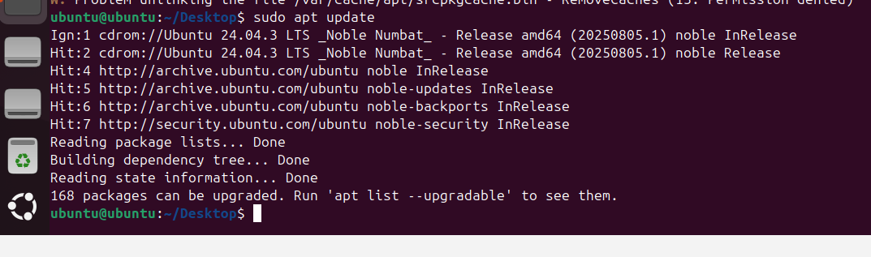

19. Create a symbolic link.
Ans : using command of ln -s filename filename _ link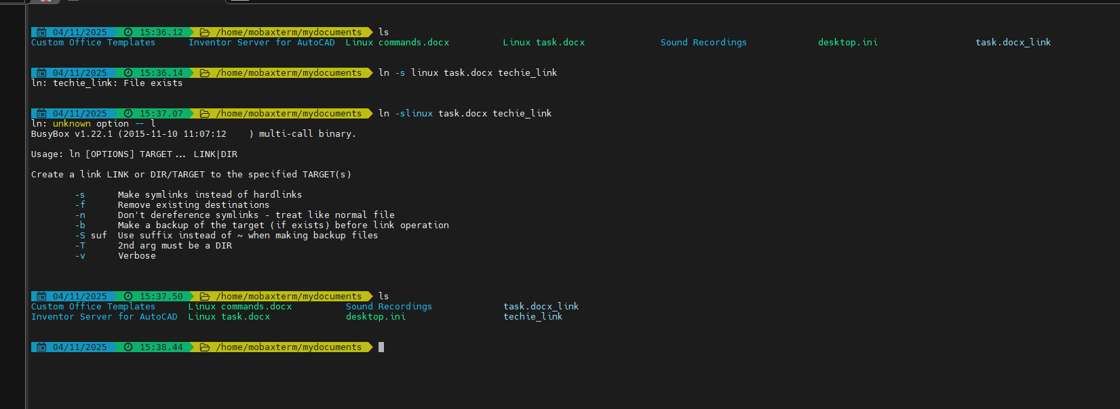

20. Search for files using the find command

Ans : using command of sudo find / -name filename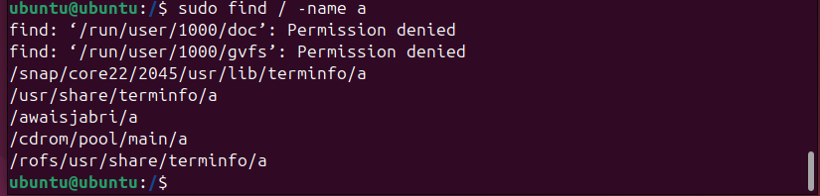

21. Compress and decompress files using tar.
Ans : to able to compress the files use the command tar cvf directory name bundle filename/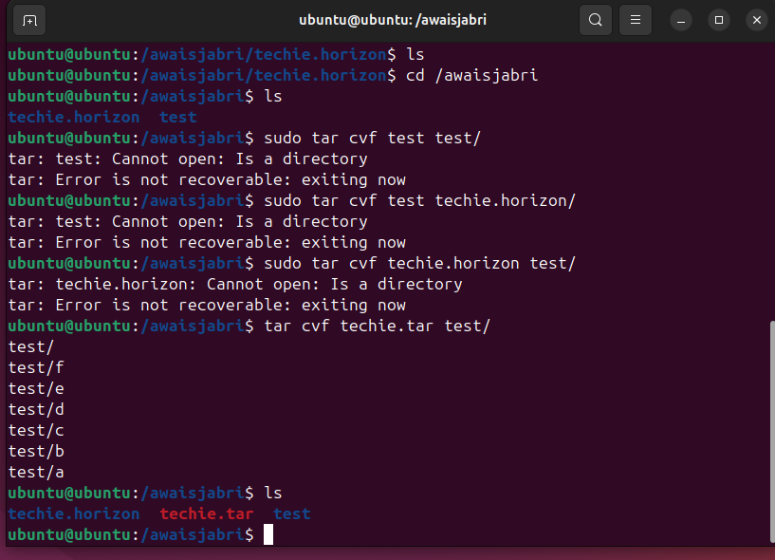

To able to decompress file use the command of
tar xvf 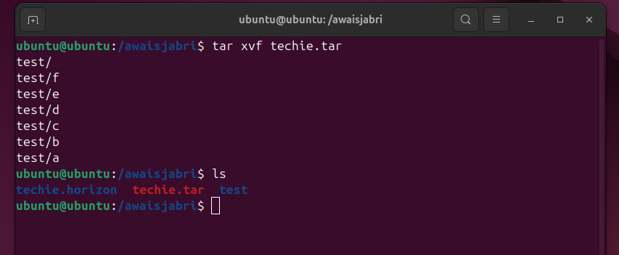

22. Monitor system resources with top or htop.
Ans : to able to view your system resources use command top 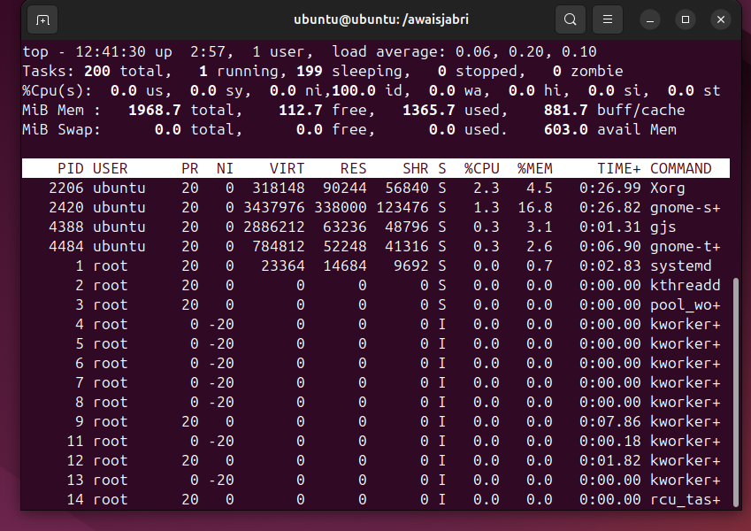
To able to under better as a human use command of htop (easier to read)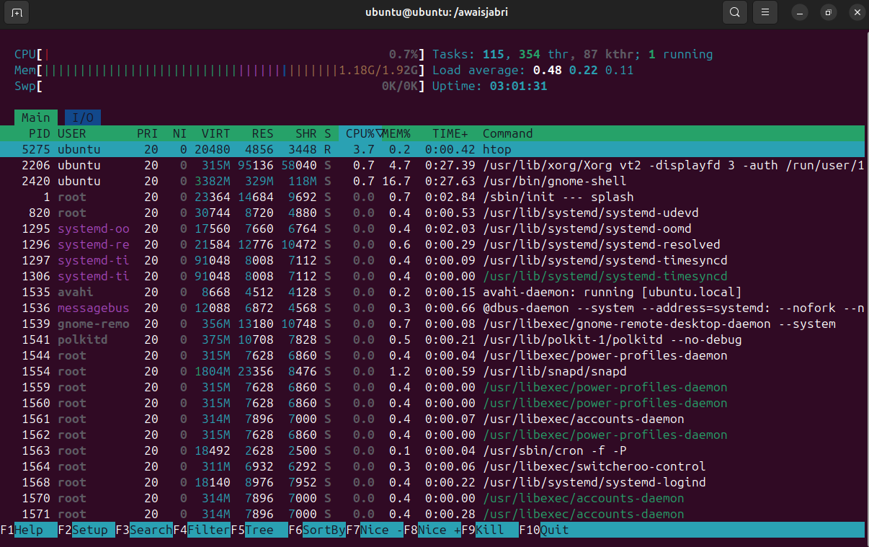

23. Create and manage user groups.
Ans: first need to create addgroup group name
then add user in that group by using command of
sudo usermod -aG group_name username
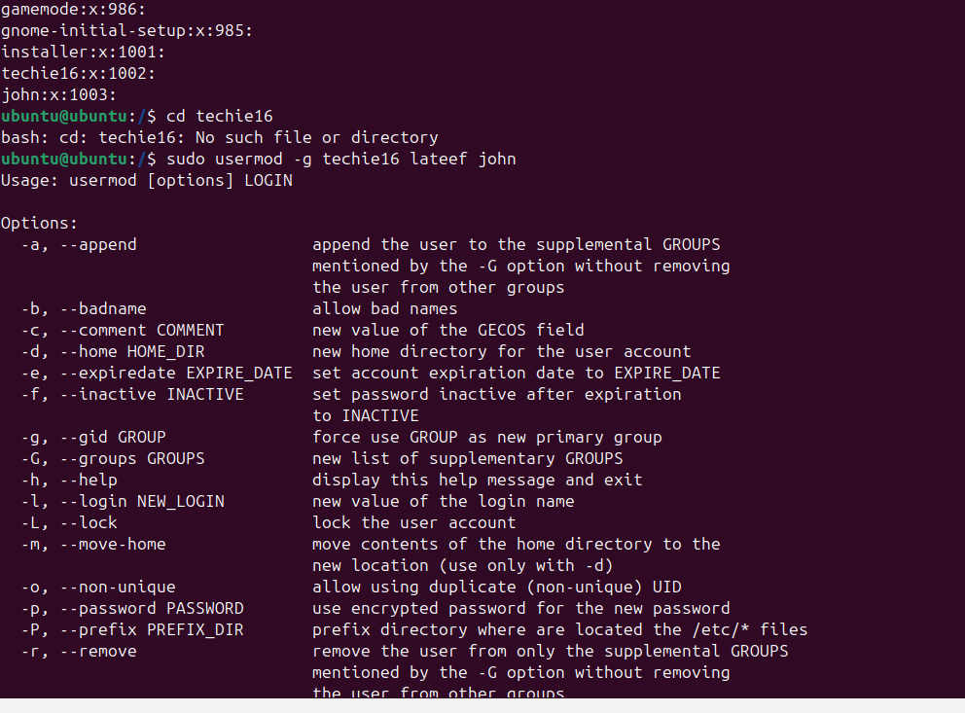

24. Set up SSH password less authentication.
Ans : lunch server with private key and open git bush run the command of password less ssh
ssh -I (privatekey file name) ec2-user@publicip

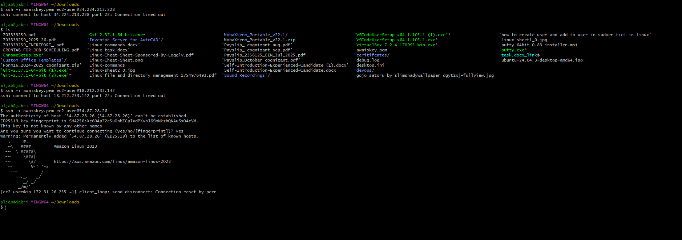

25. Monitor log files using tail or grep.
Ans: using the command of
Tail -f/var/log/syslog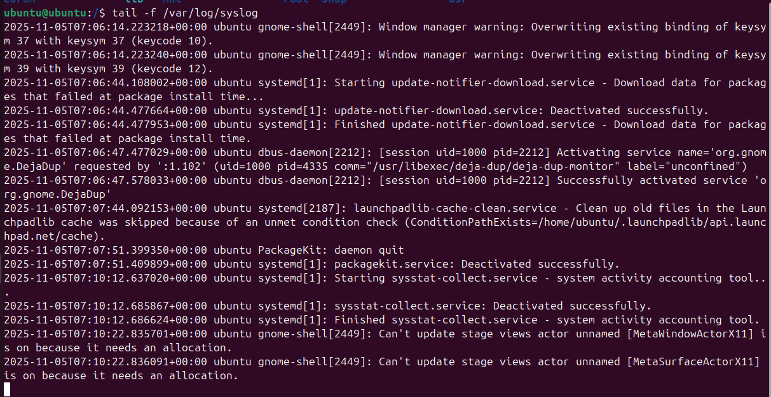

26 . Set up a web server (e.g., Apache or Nginx).
Ans: first need to install a web server software byg using command of apt install apache2
once its been install use command to start software sudo systemctl start apache2 and check the localhost in browser
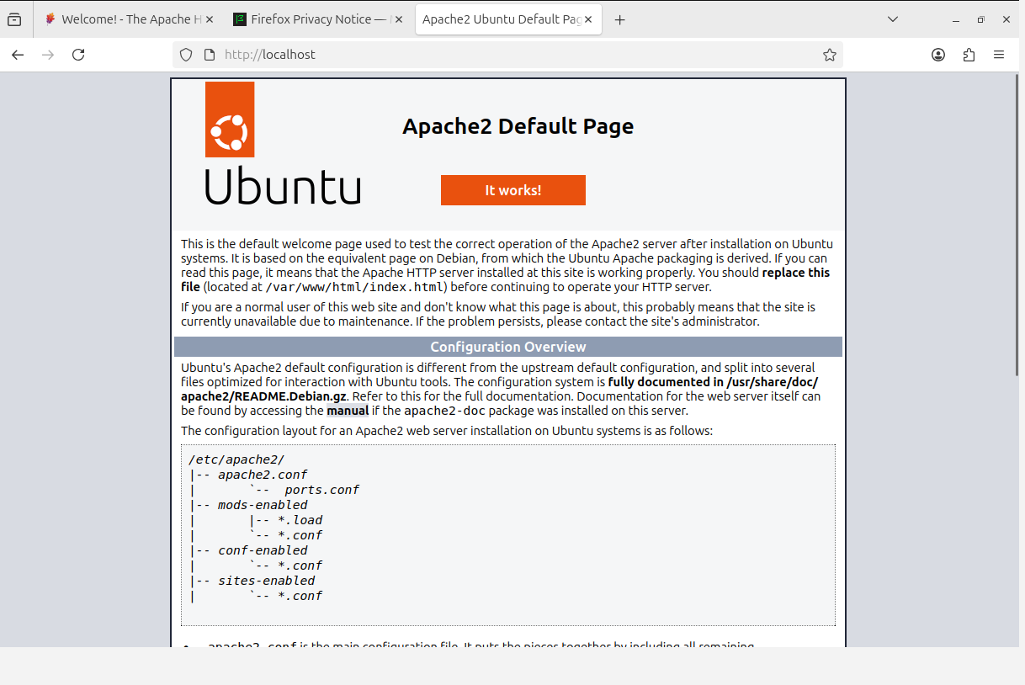

27. Configure and secure a MySQL Database.
Ans: need to install mysql in your ubuntu by using command of sudo apt install mysql -y and enable the sql and run the command to secure
: sudo mysql_secure_installation
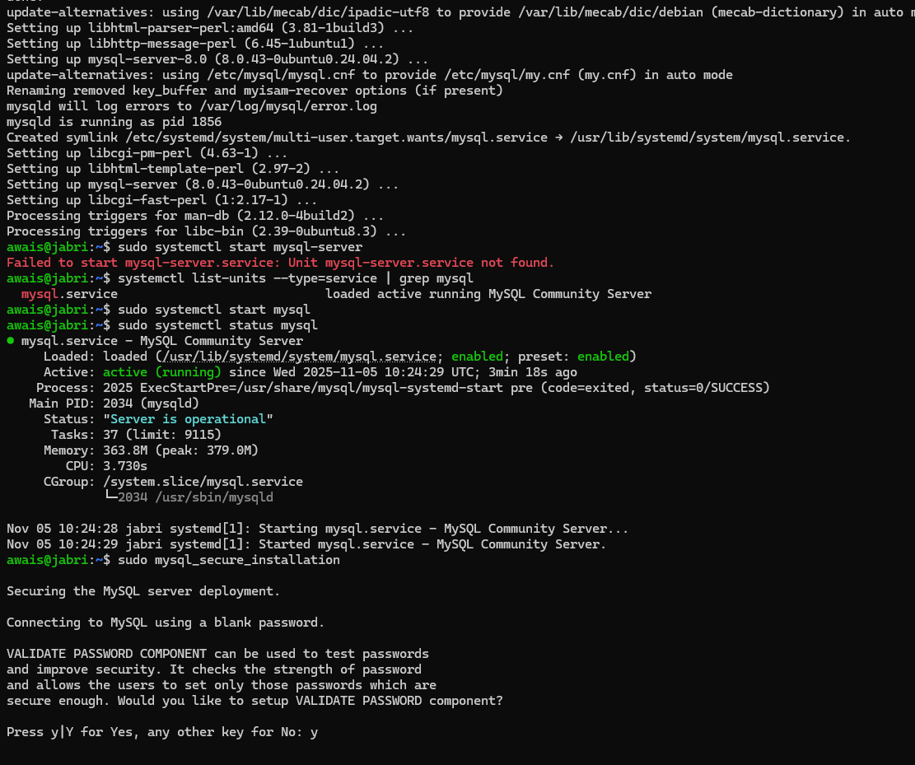

30: Print specific columns from a delimited file
Ans : using the command for just for name cut -d',' -f1 data.csv
if need name and department use command of cut -d',' -f1,3 data.csv
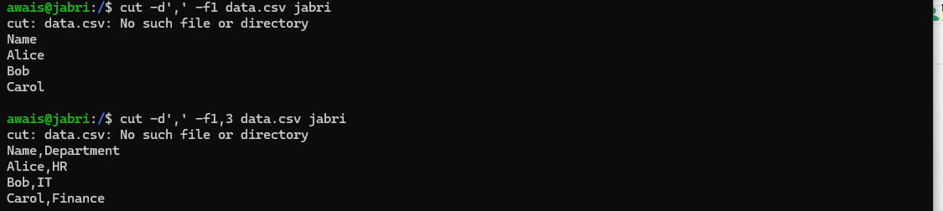

31.Filter and print lines based on a specific pattern or condition.
Ans : use the command of grep -i "word" and filename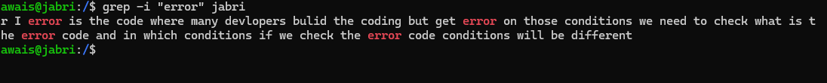

32. Calculate and print the average, sum, or other statistics of a column.
Ans : if need to check average use the command of awk '{sum += $2; count += 1} END {print "Average =", sum / count}' file name
For sum : awk '{sum += $2} END {print "Sum =", sum}' filename
For comma seprated use awk -F',' '{sum+=$3; count++} END {print "Average of column 3 =", sum/count}' filename
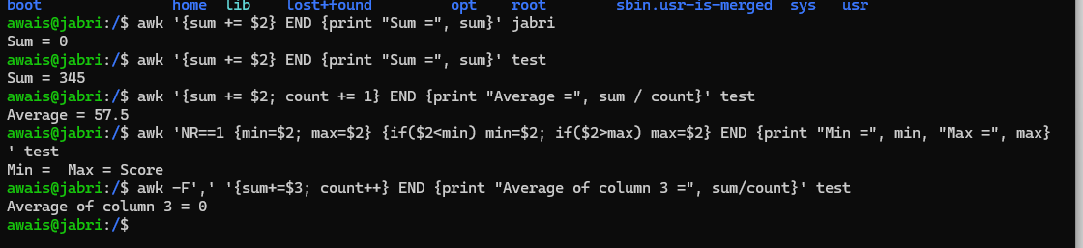

33. Perform string manipulation, such as extracting substrings or changing case.
Ans: to able to perform string manipulation use the command of str="HelloWorld" and then type echo ${str:0:5}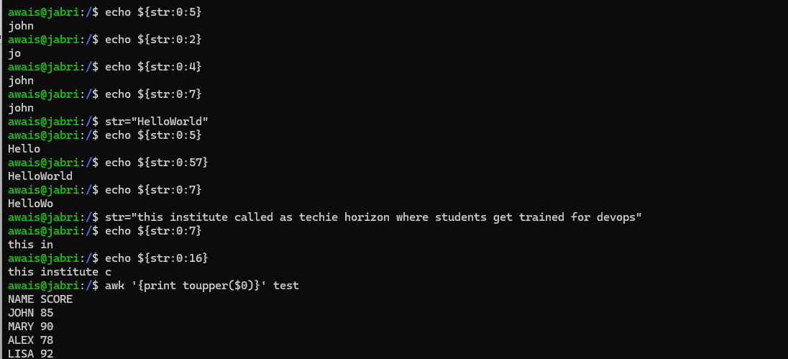

34. Count the occurrences of a specific pattern in a file
Ans : using the command of grep -o "word" filename.txt | wc -l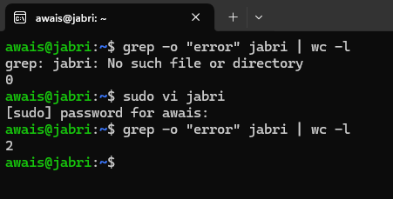

35. Sort lines based on a specific field or column.
Ans: using the command of sort -k <field_number> filename.txt to able to check number lines 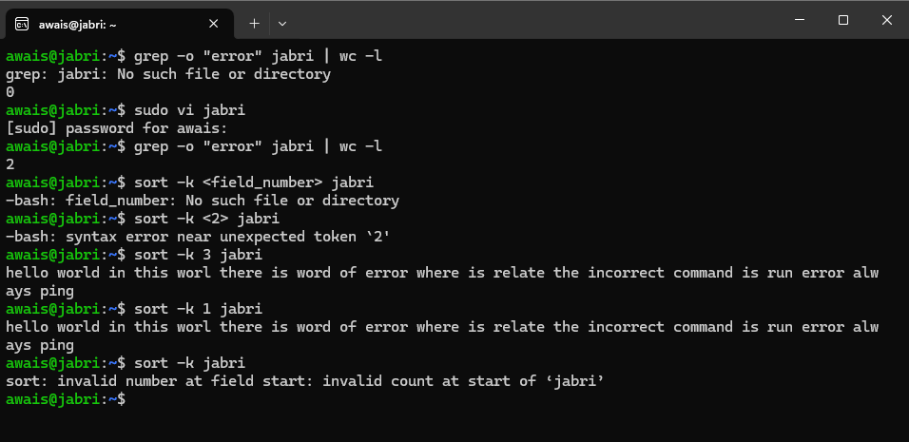

37. Substitute text in a file using search and replace.
Ans : To able to replace the substitute test in linux use the command of sed 's/search/replace/' filename.txt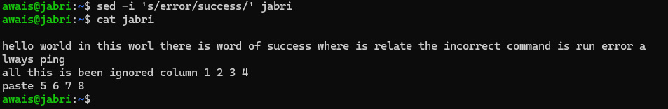

38. Delete specific lines based on a pattern or line number
Ans: to able to delete specific lines use the command of sed '/pattern/d' filename.txt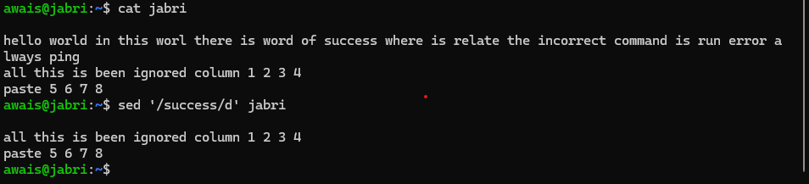

39. Append or insert text before or after a specific pattern or line.
Ans: to able to add any text before any specific word or pattern use the command of
sed '/pattern or word/i\Your new text' filename.txt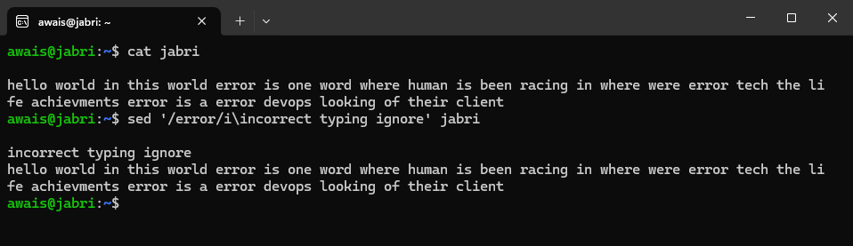

40.Print only specific lines from a file
Ans: to print specific line from a file use the command of( sed -n 'linenumberp' filename.txt)
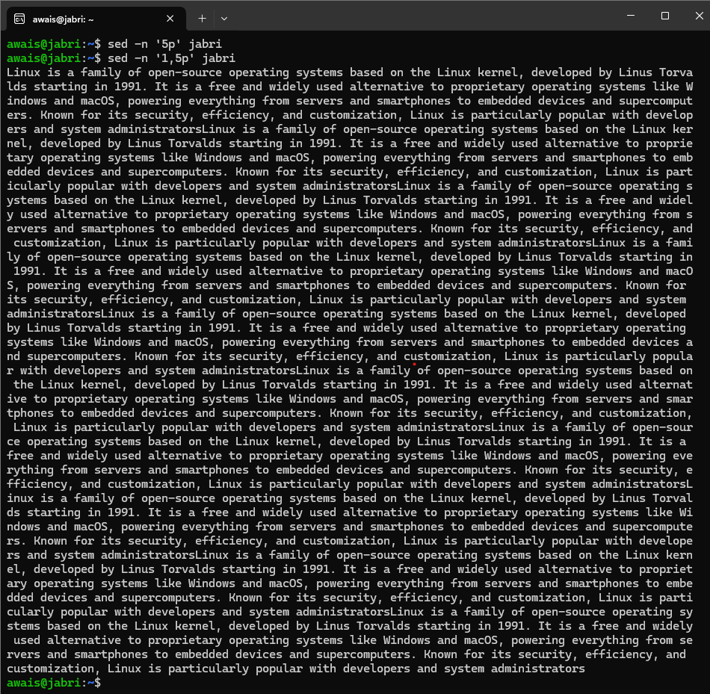
42: 5 use cases for AWK and 5 use cases for sed
Ans: the following are the Common Use Cases for awk
a. Prints the first and third columns from each line in filename.txt by using the command of awk '{print $1, $3}' filename.txt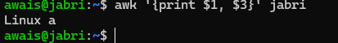
b. Adds up all values in column 2 (e.g., total sales).
Ans : use the command of awk '{sum += $2} END {print "Total:", sum}' filename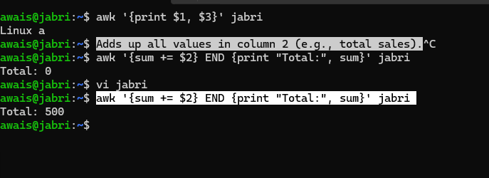
C. Prints lines where the third column is greater than 100.
Ans : use the command of awk '$3 > 100' data.txt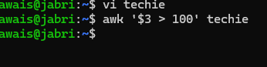
d. Pretty-prints columns into fixed-width fields.
Ans: use the command of awk '{printf "%-10s %-10s %-5s\n", $1, $2, $3}' data.txt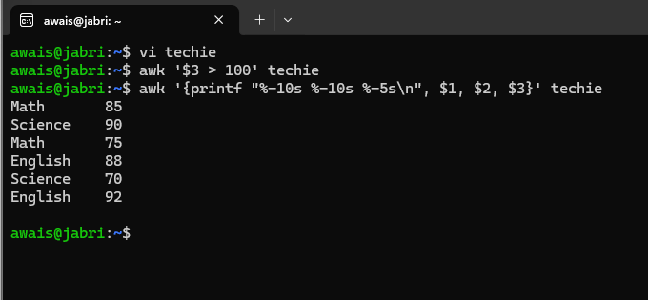
e: Counts how many times each unique first-column value appears (e.g., per-user logins).
Ans: awk '{count[$1]++} END {for (name in count) print name, count[name]}' filename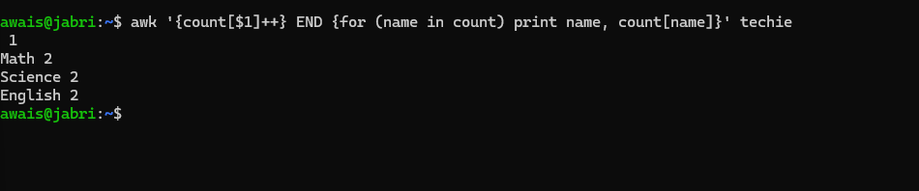
5 Common Use Cases for sed
a: • Replaces all instances of “error” with “ERROR”.
Ans : use the command of sed 's/error/ERROR/g' filename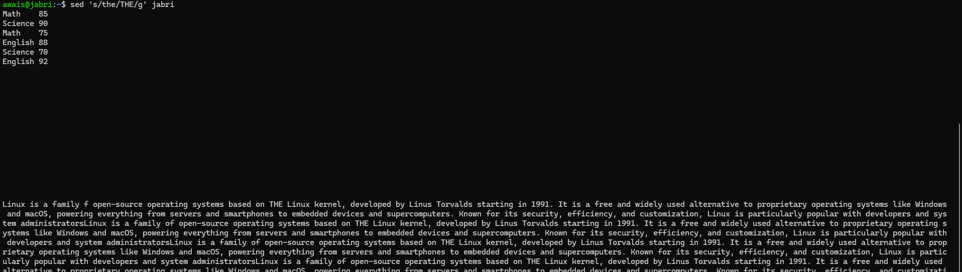
b: Deletes line 3.
Ans: sed '3d' file.txt
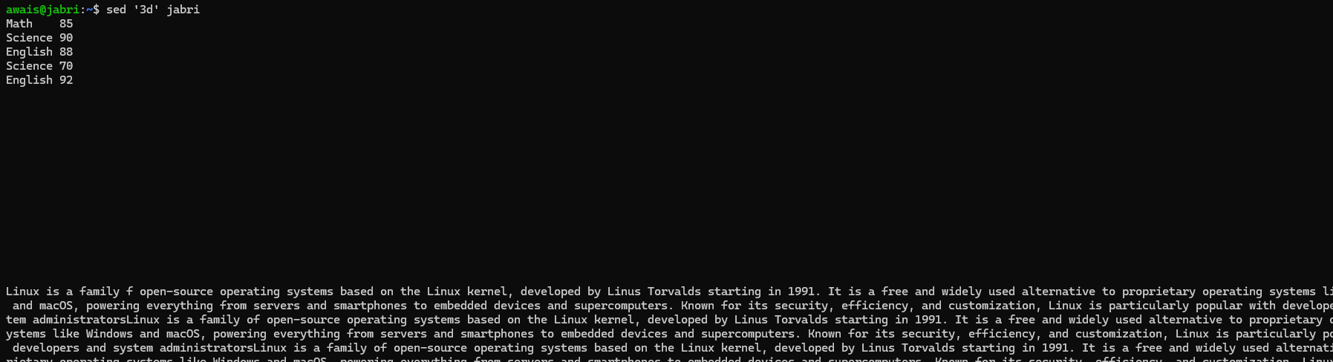

C: Inserts a new line before line 2.
Ans: use the command of sed '2i\Inserted line' file.txt
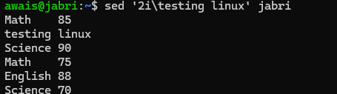

D: Replaces “foo” with “bar” only in lines 5 through 10.
Ans: use the command of sed '5,10s/foo/bar/g' file.txt
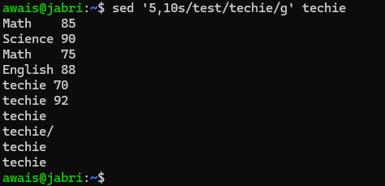
e: Prints only lines 10 to 20
Ans: use the command of sed -n '10,20p' file.txt
